Transcriptomics is the study of the transcriptome—the complete set of RNA molecules expressed by a cell, tissue, or organism at a specific time and under specific conditions. Unlike the genome, which is largely constant across tissues and cell types, the transcriptome is dynamic and changes in response to biological and environmental factors.

Gene expression varies depending on the tissue, developmental stage, and external stimuli such as drought, pathogen infection, salinity, heat stress, and herbicide exposure. By measuring RNA abundance using RNA sequencing (RNA-seq), transcriptomics reveals which genes are active, how strongly they are expressed, and how gene expression changes between different biological conditions.

Plant RNA-Seq workflow

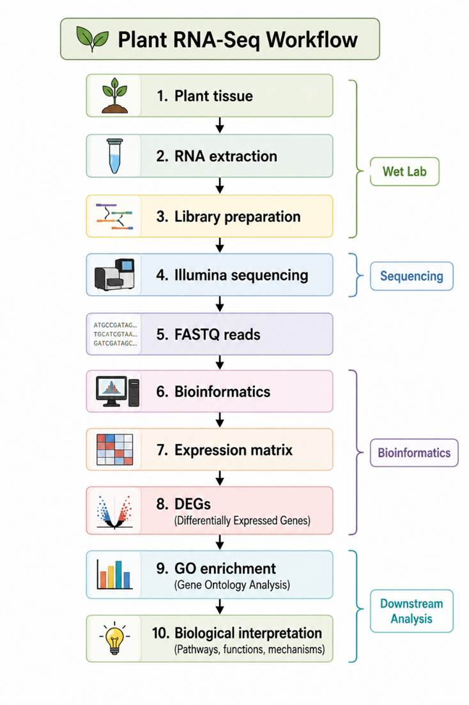
Diagram created using ChatGPT (OpenAI) based on the instructor's workflow.

Reference-guided workflow

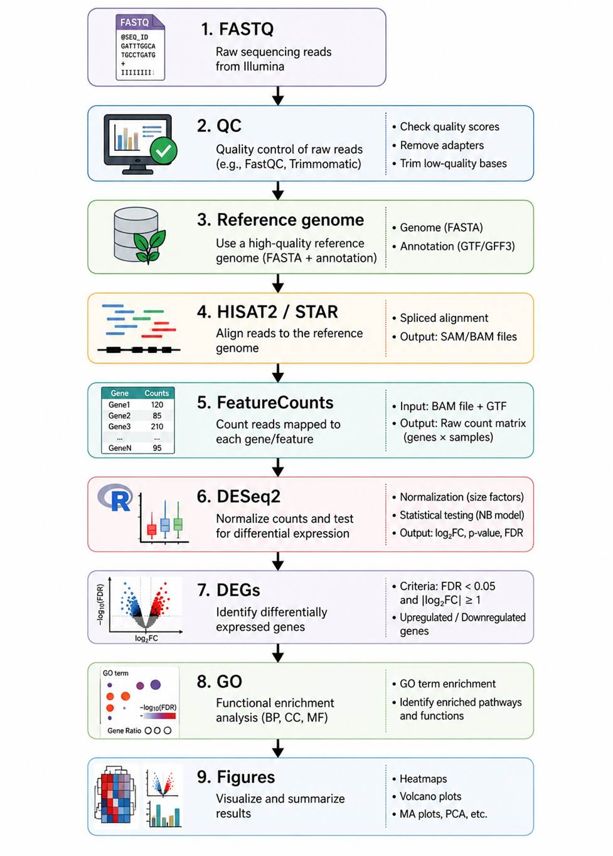
Diagram created using ChatGPT (OpenAI) based on the instructor's workflow.

De novo workflow
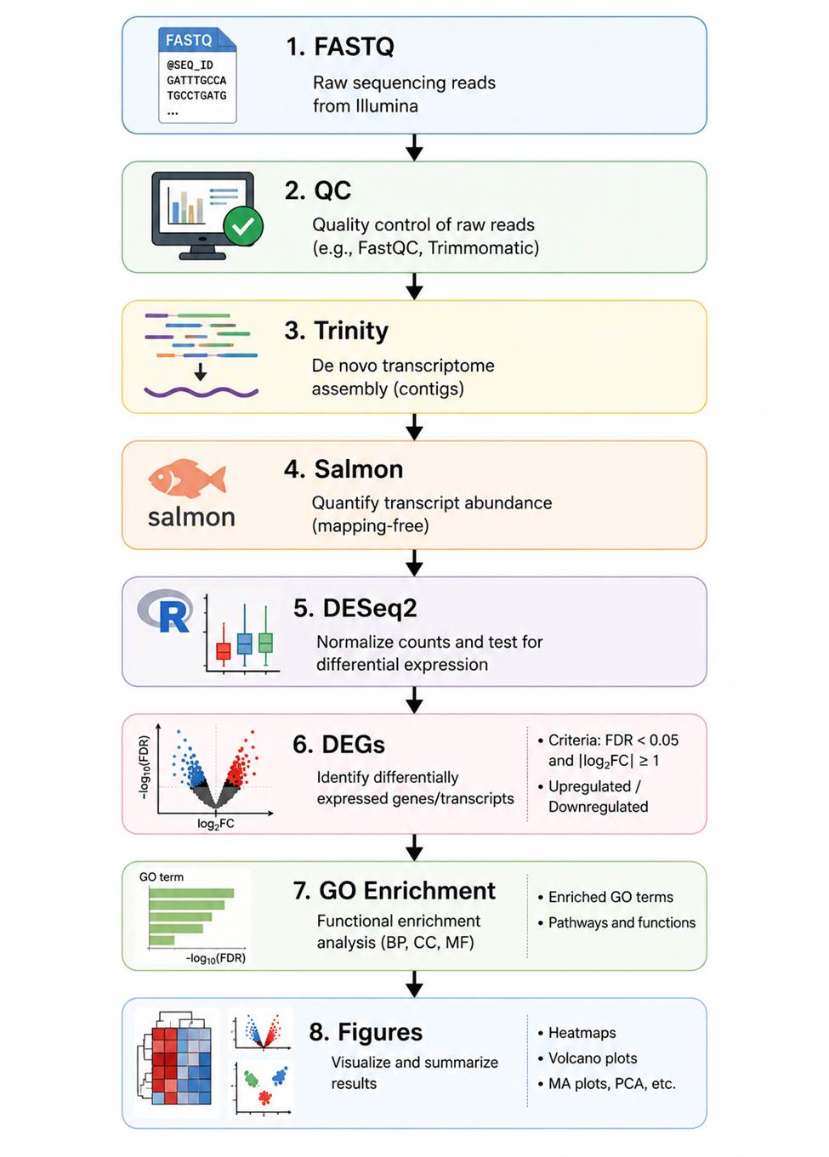
Diagram created using ChatGPT (OpenAI) based on the instructor's workflow.

Reference-guided: We already know the genome, so we align reads to known genes and count them.
De novo: We don't have a genome, so we first reconstruct the transcripts, then estimate how many reads belong to each transcript.

Feature | Reference-guided | De novo
Reference genome available? | ✅ Yes | ❌ No
Reads process | Aligned to a known genome | Assembled into transcripts first
Main goal | Quantify known genes | Discover transcripts without a genome
Accuracy | Higher | Lower (depends on assembly quality)
Novel gene discovery | Limited | Better

Gene Expression Quantification

RNA sequencing (RNA-seq) measures gene expression by counting the number of sequencing reads that map to each gene. In general, genes that produce more RNA molecules generate more sequencing reads, resulting in higher read counts and higher expression levels.

For example, if Gene A has 50 reads in the control sample and 200 reads in the treatment sample, the treatment appears to have higher gene expression. However, raw read counts cannot be compared directly because samples may have different sequencing depths (total number of reads generated).

To make expression values comparable across samples, normalization is performed. Software such as DESeq2 adjusts for differences in sequencing depth before statistical testing, producing normalized counts, log₂ fold change (log₂FC), and False Discovery Rate (FDR) to identify differentially expressed genes (DEGs).

Fold Change and log₂ Fold Change

Fold change (FC) measures how much a gene's expression changes between two conditions by dividing the treatment expression by the control expression.

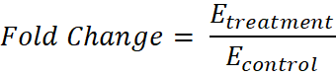

PPO1: 100 reads in the control; 400 reads in the treatment
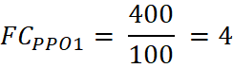

PPO2: 100 reads in the control; 25 reads in the treatment
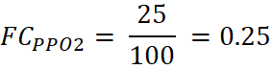

Because fold change values greater than 1 indicate upregulation while values between 0 and 1 indicate downregulation, they are not symmetrical and can be difficult to interpret. To simplify interpretation, RNA-seq analyses use the log₂ fold change (log₂FC), which transforms fold changes into values centered around zero.

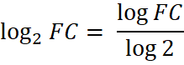

PPO1: 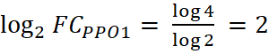

PPO2: 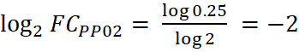

log₂FC | Interpretation
≥ +1 | Upregulated
0 to < +1 | Slight/no meaningful increase
0 | No change
−1 to < 0 | Slight/no meaningful decrease
≤ −1 | Downregulated

Statistical Significance

After estimating gene expression changes, statistical testing is performed to determine whether the observed differences are likely due to biological effects rather than random variation. Each gene is assigned a p-value, which represents the probability of observing the difference by chance.

Because RNA-seq experiments typically test thousands of genes simultaneously, many genes may appear significant simply due to random chance. To reduce false positives, p-values are adjusted for multiple testing using the FDR-adjusted p-value (padj). In DESeq2, genes are commonly considered significantly differentially expressed when they meet both FDR < 0.05 and |log₂FC| ≥ 1, indicating that the gene shows both a statistically significant and biologically meaningful change in expression.

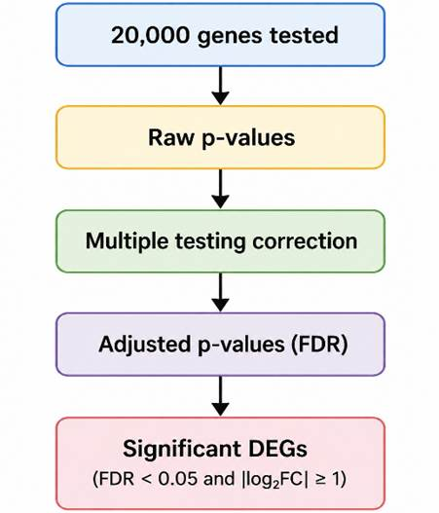
Diagram created using ChatGPT (OpenAI) based on the instructor's workflow.

Biological interpretation

Differentially expressed genes (DEGs) provide insights into the biological processes underlying a trait or response. In this example, postharvest stress activates pathways involved in polyphenol production and increases the expression of polyphenol oxidase (PPO). PPO oxidizes polyphenols into quinones, leading to the formation of brown pigments and enzymatic browning. By identifying genes and pathways that are differentially expressed, transcriptomics helps explain the molecular basis of the observed phenotype.

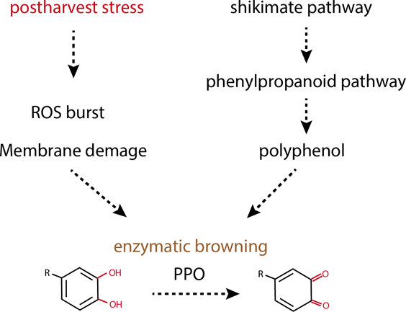
Wang, C., Meng, L., Zhang, G., Yang, X., Pang, B., Cheng, J., He, B., & Sun, F. (2024). Unraveling crop enzymatic browning through integrated omics. Frontiers in Plant Science, 15, 1342639. https://doi.org/10.3389/fpls.2024.1342639

Volcano Plots

Question answered: Which genes are significantly upregulated or downregulated between two conditions?

A volcano plot displays the log₂ fold change (x-axis) against the −log₁₀(FDR) (y-axis). Genes in the upper left and upper right are significantly downregulated and upregulated, respectively, while genes near the center show little or no expression change.

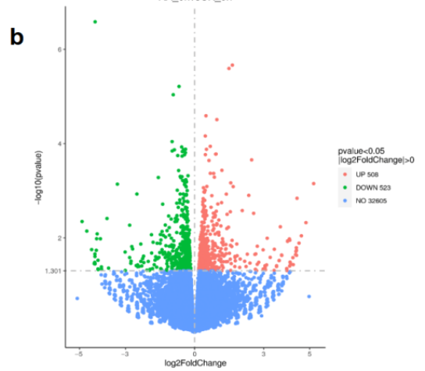 | Figure 7. (b) The volcano plot of the differential genes between Lys/Arg and control group at 0 h.  Liu, Y., Wang, S., Yuan, K., Li, Y., Ding, Q., Shi, J., Zhang, S., & Liu, P. (2026). Transcriptomics explored the molecular mechanism by which l-lysine/arginine inhibits fresh-cut apple browning. Horticulturae, 12(2), 210. https://doi.org/10.3390/horticulturae12020210

Venn diagram

Question answered: Which differentially expressed genes are unique or shared among different comparisons or treatments?

A Venn diagram summarizes the overlap of DEGs between multiple conditions. Shared regions indicate common gene responses, whereas non-overlapping regions represent genes unique to a specific treatment or comparison.

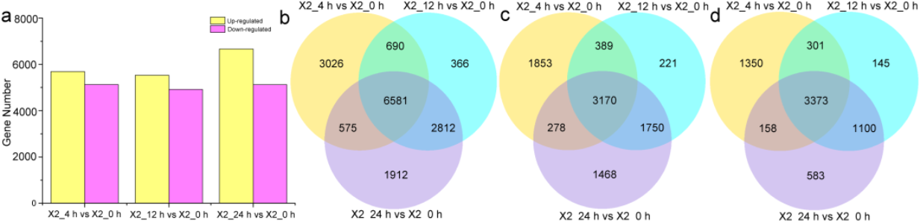
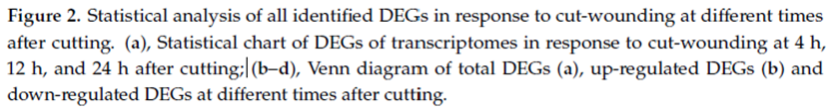 | Wang, L., Wang, W., Shan, J., Li, C., Suo, H., Liu, J., An, K., Li, X., & Xiong, X. (2023). A genome-wide view of the transcriptome dynamics of fresh-cut potato tubers. Genes, 14(1), 181. https://doi.org/10.3390/genes14010181
GO enrichment

Question answered: What biological functions or pathways are affected by the differentially expressed genes?

GO enrichment groups DEGs into Biological Process (BP), Cellular Component (CC), and Molecular Function (MF) categories. Larger dots indicate a higher proportion of genes associated with a GO term, while darker colors represent more statistically significant enrichment.

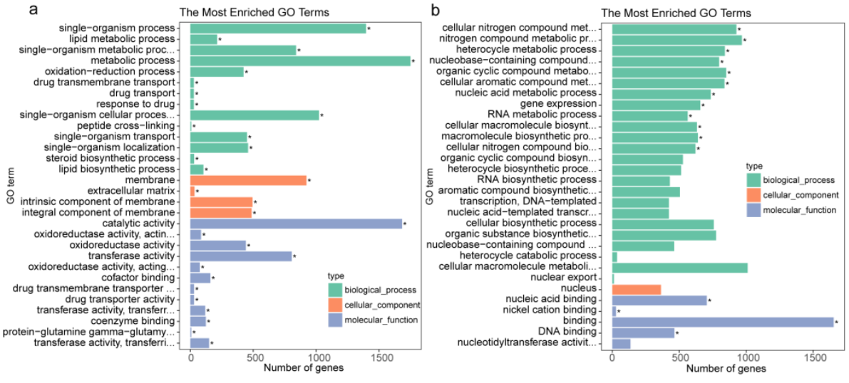
Figure 3. GO terms of the functional categorization of up- and down-regulated DEGs of all common DEGs at different times in response to cut-wounding. Significantly enriched GO terms are indicated by * for a p-value less than and equal to 0.05 | Wang, L., Wang, W., Shan, J., Li, C., Suo, H., Liu, J., An, K., Li, X., & Xiong, X. (2023). A genome-wide view of the transcriptome dynamics of fresh-cut potato tubers. Genes, 14(1), 181. https://doi.org/10.3390/genes14010181

Heatmaps

Question answered: How do gene expression patterns vary across samples or treatments?

A heatmap visualizes the expression levels of multiple genes across samples using a color scale. Genes or samples with similar expression profiles cluster together, making it easier to identify co-expressed genes and treatment-specific expression patterns.

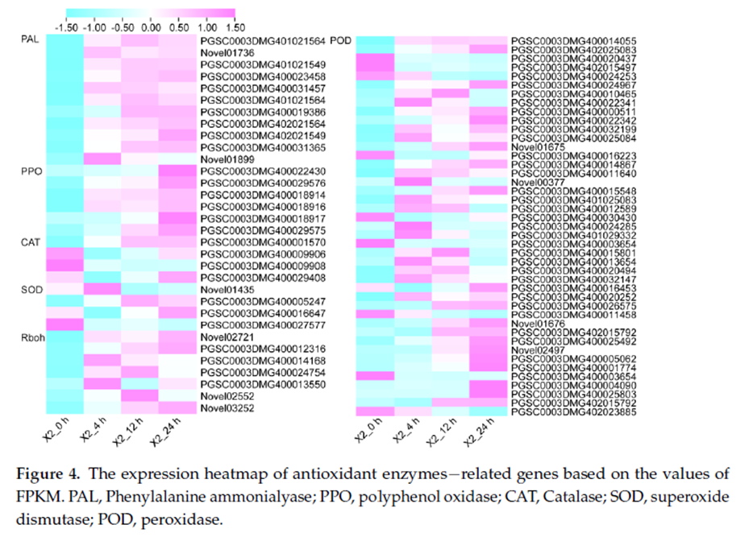 | Wang, L., Wang, W., Shan, J., Li, C., Suo, H., Liu, J., An, K., Li, X., & Xiong, X. (2023). A genome-wide view of the transcriptome dynamics of fresh-cut potato tubers. Genes, 14(1), 181. https://doi.org/10.3390/genes14010181

Gene Expression Validation by qRT-PCR

RNA sequencing measures the expression of thousands of genes simultaneously, whereas quantitative reverse transcription PCR (qRT-PCR) is commonly used to validate the expression of selected genes identified from RNA-seq analysis. Total RNA is first converted into complementary DNA (cDNA) by reverse transcription, after which the cDNA is amplified and quantified by real-time PCR. The accumulation of fluorescence during amplification is measured to determine the expression level of the target gene relative to a reference gene.

Ct (Cycle Threshold) Value

The Ct (Cycle threshold) value is the PCR cycle number at which the fluorescence signal exceeds a predefined threshold above the background. A lower Ct value indicates that more target RNA was present in the sample (higher gene expression), whereas a higher Ct value indicates lower gene expression.

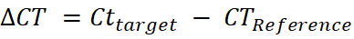

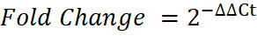

Example:

Sample | PPO1 (Target) Ct | Actin (Reference) Ct | ΔCt
Control | 24 | 20 | 24 − 20 = 4
Treatment | 22 | 20 | 22 − 20 = 2

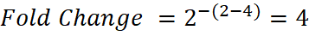
Interpretation: The PPO gene is expressed 4-fold higher in the treatment than in the control.

Interpretation of qRT-PCR Results
The qRT-PCR results are commonly presented as relative fold change (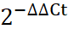) with error bars representing biological replicates. A fold change greater than 1 indicates gene upregulation, whereas a value less than 1 indicates downregulation relative to the control. When qRT-PCR expression patterns agree with RNA-seq results, they provide independent validation of the identified differentially expressed genes.

Capstone Integration of Module 8:
https://docs.google.com/document/d/1Z3aMmY-mb6MpNnPAPvEdAEpTQncf19Heo4i0d4os28I/edit?tab=t.0

